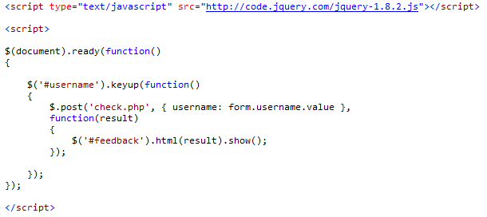

Figure 1: register.html

Before we start checking for username duplication, we need to attach the source for jquery first, where ‘text=”text/javascript”’, and ‘src=”http://code.jquery.com/jquery-1.8.2.js”’. Then we can start the function for jquery.

Firstly, a new function is prepared with “$(document).ready”. After that, a new function is set when user clicks on the input text box, where ‘#username’ is the id of input text box. When user clicks on the input text box, text field is then posted to ‘check.php’ using “$.post”. Then we declare a variable “username” for the value of username inside the form.

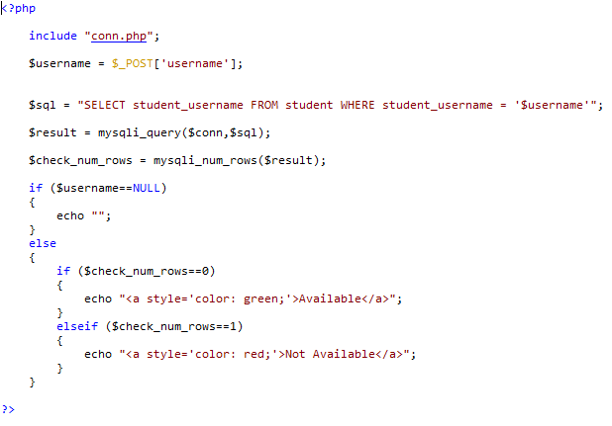

Figure 2: check.php

First, “conn.php” is included in this page to ensure that it is connected to database without any error. A variable “$username” is declared as the posted value from ‘username’, which is the value of username inside the form from the previous page.

Then, a new query is written and declared as $sql, which is “SELECT student_username FROM student WHERE student_username = ‘$username’ ” ;. The query is then executed with “mysqli_query($conn,$sql);” attaching with a new variable “$result”.

After the query is executed, if the input field is NULL or empty, it will display nothing. If $check_num_rows==0, means that database has nothing match with the input field, and the input username is valid to register. Thus, it will display “Available” with green background color. Other than that, if there is any username in database matches with input field, it will display “Not Available” with red background color, which needs user to enter a new username again.